Matchborough and Winyates District Centres
Public Consultation: Headline Comments
Introduction
A period of public consultation was undertaken at both Matchborough and Winyates District Centres to gauge public perception of the current state of the District Centres and what improvements they would like to see in the future. Officers were able to record views from a good cross section of the population ranging from primary school children to the elderly population through a series of targeted consultation events.
Consultation events were held as follows:
Views about Matchborough District Centre only
Christ Church - All public | 21 October 2016
Christ Church - Youth Group | 21 October 2016
Christ Church - Lunch Club for the elderly | 27 October 2016
Matchborough First School pupils | 1 November 2016
Views about Winyates District Centre only
The Space - All public | 18 October 2016
The Link - All public | 18 October 2016
Views about both District Centres
RBC Stakeholder event | 10 October 2016
Christ Church - All public | 24 October 2016
RSA Academy Arrow Vale pupils | 4 November 2016
Ipsley RSA Academy pupils | 4 November 2016

Planning officers used a Planning for Real® tool whereby members of the public placed topic cards on a 3D map base indicating where they perceived issues to be, what solutions could be put in place and their aspirations for the District Centres in the future. The topic cards are colour coded by category as follows:
Dark Blue: | Work, Training, Education
Dark Green: | Local Environment
Grey: | Health
Light Green: | Leisure
Orange: | Crime & Safety
Pink: | Community Facilities
Red: | Traffic & Transport
Yellow: | Housing

Overall, a total of 2188 responses were received, 1395 responses were recorded for Matchborough District Centre and 793 responses were recorded in relation to Winyates District Centre.
Below is an example of the 3D board with issues cards placed. These are recorded at the end of the consultation session and transferred into spreadsheets for analysis.
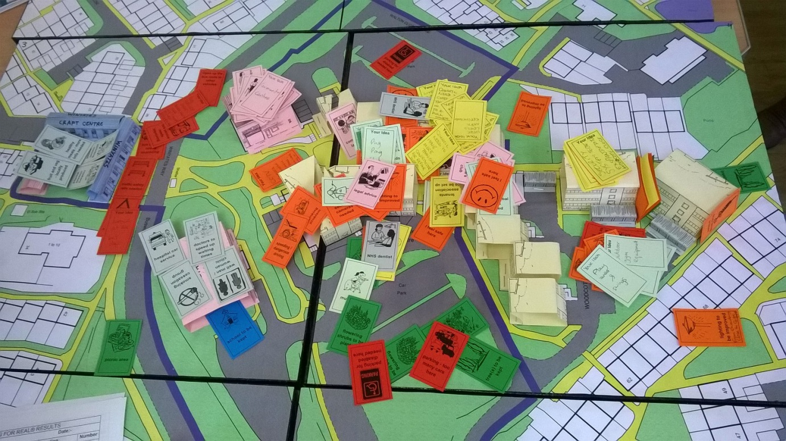
Consultation event at The Link, Winyates District Centre, 18 October 2016

Headline Issues - Matchborough District Centre

In relation to Matchborough District Centre, an overwhelming number of responses related to making better use of the vast amount of open space around the District Centre (Local Environment (23%) and Leisure (17%)). Better designed open space provision could alleviate the negativity associated with the younger population by providing appropriate areas for leisure and community activities thereby reducing the need for them to hang around ‘on street corners’. There is a clear desire to improve the pond and surrounding green spaces to create a focal point for everyone’s benefit, to enhance these assets and create a stronger sense of community. There is also a desire to improve community facilities and the general sense of community within the District Centre.
By way of contrast, the majority of negative responses relate to the Crime and Safety category (21%) and in particular in relation to young people hanging around, people feeling unsafe or afraid to go out at night, which could in part be attributed to poor lighting and lack of appropriate youth facilities which were also identified.
The following graphs depict the most frequently placed topic cards, showing all results where at least five cards were placed on the 3D maps. The graphs also depict the locations where topic cards were most frequently placed, which gives a good indication of the locations that need to be considered as concept plans are advanced.

Local Environment

Leisure

Crime & Safety

Community Facilities

Traffic & Transport

Housing

Headline Issues - Winyates District Centre

In relation to Winyates District Centre, an overwhelming number of responses related to the Crime and Safety category (24%) and in particular in relation to drug taking/ dealing and people feeling unsafe and afraid to go out at night, which could in part be attributed to poor lighting, which was also identified.
By way of contrast, there is an overwhelming sense of community within Winyates District Centre, which is underpinned by the number of responses relating to Community Facilities (16%) and Health Facilities (10%). People were generally happy with the District Centre and felt that it didn’t necessarily need demolishing and rebuilding, and they were keen to keep existing facilities such as the Health Centre, The Space and The Link in any plans moving forward.
There is a desire to make better use of the green spaces in the District Centre (Local Environment and Leisure) (13% and 9% respectively), which are currently very fragmented. This would underpin the sense of community within the District Centre, which regularly plays host to street theatre/ community events.
Housing related issues are more prevalent in Winyates District Centre due to the large number of residential units within the District Centre boundary.
The following graphs depict the most frequently placed topic cards, showing all results where at least five cards were placed on the 3D maps. The graphs also depict the locations where topic cards were most frequently placed, which gives a good indication of the locations that need to be considered as concept plans are advanced.
Local Environment

Leisure

Crime & Safety

Community Facilities

Traffic & Transport

Housing

