Annotated nomination papers – 2 May 2024
- Process and forms
  - Generally, there are three forms you must submit to make your nomination valid:
- Nomination form
- Home Address form
- Consent to nomination
You must deliver these forms by hand, and they must be originals -so not copies. Any documents sent by email or fax will not be accepted.
  - If you are standing on behalf of a registered political party, you will also need to submit:
  - a certificate of authorisation
  - an emblem request form, if you want an emblem on the ballot paper
These can be delivered by hand or by post but must be originals. Any documents sent by email or fax will not be accepted.
  - You may also submit an agent appointment form. This does not need to be submitted with your other nomination forms but must arrive before the deadline to be accepted. If you do not submit an agent appointment form, you become your own agent by default.
  - If you have any issues with completing your nomination forms, please contact the Election Office.
  - It is a good idea to have your nomination paperwork informally checked by the elections office before you formally submit it. This can allow you to make corrections or complete new nomination forms if there are any mistakes.
  - Once your nomination is formally submitted you cannot amend any details. But if you change your mind and no longer want to stand for election, you can withdraw your nomination until 4pm on 5 April 2024.

2 Further Information
Other useful guidance sources
Guidance for Candidates and Agents at local government elections in England
The Local Elections (Principal Areas) (England and Wales) Rules 2006

- Annotated forms
These annotated forms cover areas of common confusion or difficulty for you to refer to as you complete your nomination paper.
Notes have been added to draw attention to areas where mistakes are often made, or where you are likely to have questions.

Form 1a – Nomination paper (header)
This section should be completed by election staff when the form is formally submitted.

Should be deleted to show if there is one or more vacancy in the division/ward.

The division or ward you are standing in should be added here.

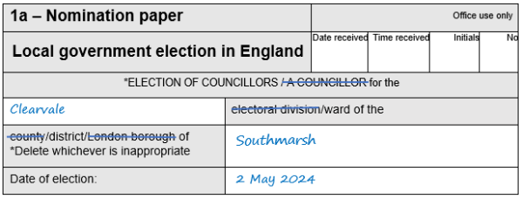
The name of the council should be added here.
E.g., if you are standing for a ward in Redditch Borough Council, Redditch should be added here.
If you put the council’s name in full this would not invalidate the nomination.
If it has not been pre-printed, the date of the election should be added here.

Form 1a – Nomination paper (Candidate’s details)
The Candidate’s details section must be completed in full before any electors sign the nomination paper

It is not vital to complete this.
Titles will not appear on the ballot paper or other notices.

Full names must be added here – no initials.
Prefixes like Sir, or suffixes like Snr, must not be used.

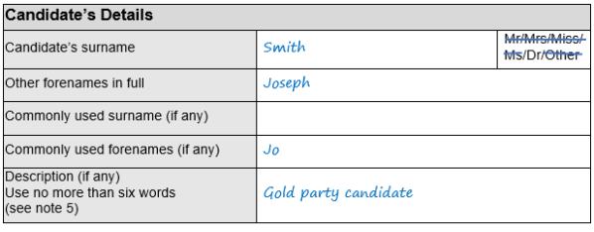
This is optional.
If you are commonly known by a different name to your actual name, you should enter it here. Or, if you use one or more of your names given on your nomination paper in a different manner (e.g. if you are known by your middle name), you should enter it here.
The commonly used name will appear on the ballot paper and Statement of Persons Nominated instead of your actual name.
It is important to read Electoral Commission Guidance if a commonly used name is used.

The description may be left blank.

OR you could use the description ‘Independent’.

OR - for political party candidates, you will need to enter the registered party name or description as authorised by the party. This must be as registered with the Electoral Commission, and must match EXACTLY with the description authorised on Form 2 – the Certificate of Authorisation.

It is important to read Electoral Commission Guidance if a description is used.

Form 1a – Nomination paper (subscribers)
Should be deleted as necessary.

You should include the polling district reference and elector number from the register in force when the Notice of Election is published.

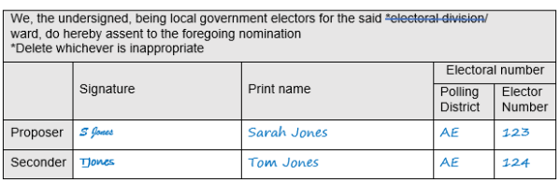

The form must be signed by two registered electors, a proposer and seconder from the relevant division/ward.
We can help you with elector numbers if you tell us the full name and address of each subscriber. Contact us on 01527 881421 or email elections@bromsgroveandredditch.gov.uk
Each subscriber must sign the nomination form in the signature column. Their name must be printed too, preferably in capitals, and does not have to exactly match the name printed in the electoral register.
An elector must not sign more nomination papers than there are vacancies in the ward. If subscribers sign more nomination papers than there are vacancies, their signature will only be valid on the first papers delivered to the Returning Officer.
For further information see the Electoral Commission Guidance.

Form 1b – Home address form (header)

This section will be completed by election staff when your form is formally submitted.

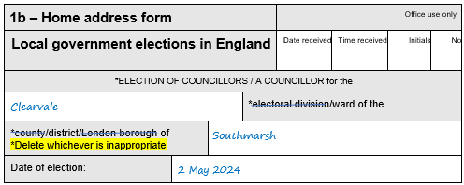
If it has not been pre-printed, the date of the election should be added here.
The name of the council should be added here.
If you are standing for a ward in Redditch Borough Council, Redditch should be added here.

The division or ward you are standing in should be added here.

Form 1b – Home address form (Part 1)
Your home address must be given here:
- in full and without any abbreviations
- it must be your current home address
- it must not be a business address (unless you run a business from your home).
For further information see the EC guidance.

All candidates must complete Part 1 of Form 1b

This should be your actual full name, rather than any commonly used name.

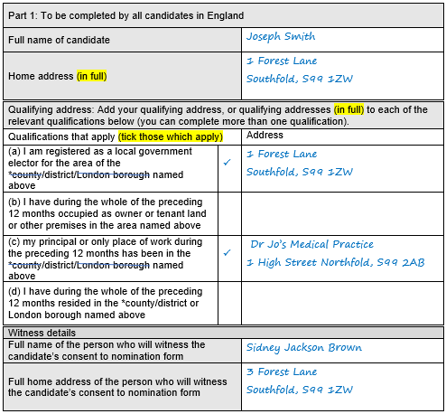
A full address should be written next to each qualification that applies to you.
If relevant, a different address may be used for each qualification.
At least one must match information you give on Form 1c.

There are no restrictions on who can be a witness, but the same person must also witness Form 1c.

Form 1b – Home address form (Part 2)
Candidates who do not want their home address printed on the ballot paper must complete and sign Part 2 of Form 1b.
Part 2 should be submitted whether it is completed or not.

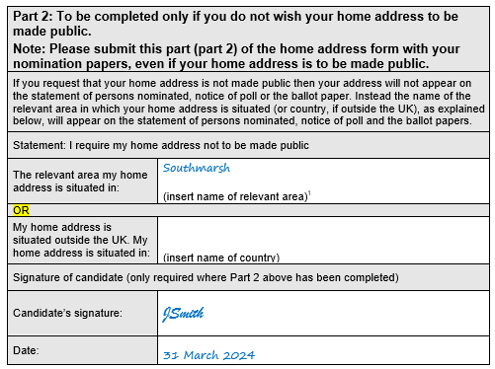
The relevant area is the county/district/London borough your home address is in.
For example, if your home address is in the Redditch Borough Council area, the name of the relevant area is ‘Redditch’.
For more information see the Electoral Commission Guidance.

If either of the two boxes above have been completed the form must be signed and dated.

Form 1c – Consent to nomination
The entire form must be submitted.

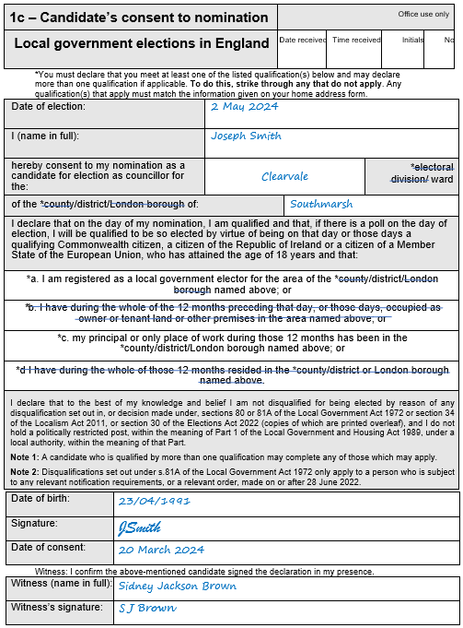
This should be your actual full name (rather than commonly used name) as given in Form 1a.

You must be 18 or over on the date the nomination paper is submitted.

You must sign here, and the date should not be earlier than
5 March 2024.
This must be the same person who witnessed Part 1 of Form 1b.

You must strike through any qualification that does not apply, leaving at least one not struck through.
The qualifications which apply must match the information you give in Part 1 of Form 1b.

Form 2 – Certificate of authorisation
For party candidates only

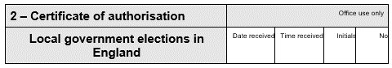
If you are authorised to use a specific registered description or party name, it should be written here. It must match the description you give on Form 1a.
Or, if you are authorised to choose from a range of registered descriptions or party names, it should say ‘any registered description or the party’s name as registered with the Electoral Commission’.
Check the Electoral Commission website for descriptions.

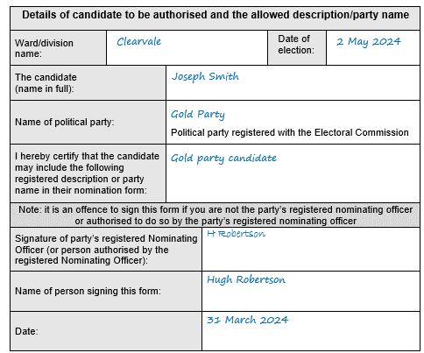
Must be signed by the party’s Nominating Officer or someone authorised by them

Registered party names and descriptions can be found on the Electoral Commission website
Search the registration details of the party and
click for more details to view the descriptions
available to choose from.

Form 3 – Emblem request form
For party candidates only

(To request an emblem as registered with the EC)
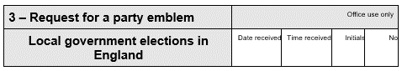
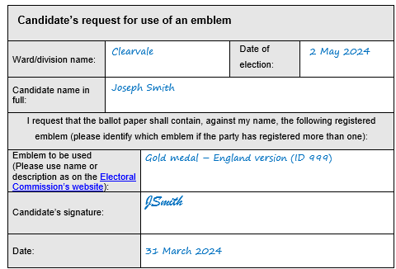
This must be signed by you.

This should be the name registered with the Electoral Commission e.g., “Emblem for use in England” or “Emblem ID 999”.

Emblems can be found on the Electoral Commission website by searching the registration details for the party and clicking for more details to view the emblems

Form 4 – Agent notification form
Optional – if you do not appoint an agent, you will become your own agent by default.

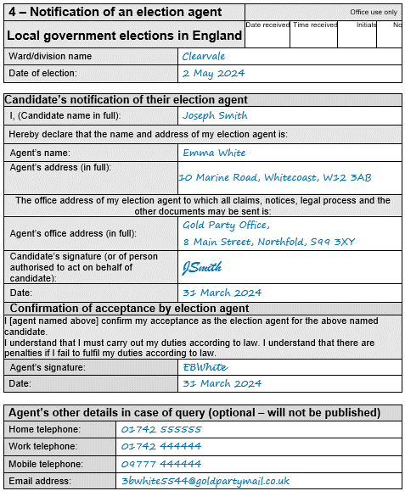
It is useful to provide this information in case of query or follow up contact.
Must be a physical address, within the council area, or in a constituency within the local government area, or in a district, borough, Welsh county/ county borough adjoining it.
The agent’s office address will appear on the Notice of Election Agents.

If you appoint yourself as your election agent, but are withholding your home address from the ballot paper and do not want it to appear on the Notice of Election Agents, you can provide an office address which is different to your home address.
For more information see the Electoral Commission guidance

Appendix A – Example of correctly completed nomination
