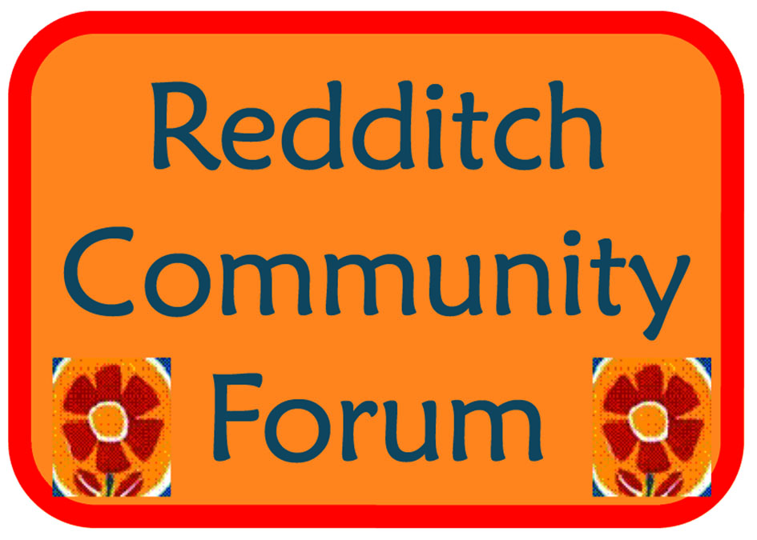

Redditch Community Forum

DRAFT minutes of meeting on
Tuesday 6 March 2018

Present
21 residents/community representatives

- Welcome
Everyone was welcomed by the Chair, Sue Yeng, with an overview of Chinese New Year celebrations that had been taking place.
Introductions were made and apologies noted as above. The minutes from the meeting in December were approved.

Sue thanked the group - very proud that the forum has achieved so much, and thankful that that the Council keeps communities a priority.
Acknowledgements made to all involved and thank you to those supporting the forum, with special recognition to the voluntary sector.

- Councillor Pat Witherspoon
- Recognition was given to the work of the voluntary sector and thanks given to those volunteering.
- Information shared on the Church Hill Clean up taking place this week.
- Forum encouraged to recognise the importance of the Arrow Valley funding bid that Neil will present to the Forum about later.
- Thursday 15th March – Services Showcase for people aged over 55 at Redditch Town Hall – whole range of services and demonstrations from local Tai Chi and Gospel Choir groups. Please come along!

- Presentation on Recycling in Redditch
Anna Wardell-Hill gave a presentation about recycling in Redditch (presentation attached).

Information about the recycling process and data in relation to Redditch was shared. The topic was of great interest to the forum, with many questions:
- Why is foil not recycled in our green bins?
  - Not enough is collected to build enough weight to send off for recycling. Foil can be recycled at Redditch household tip and recycling centre.
- Is there a risk we need to ensure we send enough rubbish to the incinerator to make it worthwhile cost wise?
  - We don’t need to ensure we fill it, other authorities can access it too.
- Why can’t we put food waste into our brown bins?
  - After the foot and mouth outbreak, regulations came in to prevent agricultural waste being mixed with food waste to prevent the spread of disease when this is put back into farming.
- Lettuce in the garden has gone to seed – is it food or garden waste?
  - Any food that has entered your home cannot go into the brown garden waste bin – only garden waste is to be put in the bin as we cannot guarantee or check if food has gone into your home.
  - Pruning’s, weeds, dead plants and grass cuttings are acceptable.
  - There has been a good take up on garden waste bins.
- Previously there was a big focus on home composting – concerns that garden waste bins have stopped that happening/taken the focus off home composting.
  - Garden waste bins are aimed at those who cannot compost at home. It was raised by residents as huge importance to them, and through consultations the need/want for garden waste bins was so high we needed to act on this.
- For those who cannot drive, is there anyway a scheme could be put in place to support them to get recycling to the Redditch household tip and recycling centre to encourage wider recycling?
  - Eco n Wise could look at this
- Tip Shops? Could these be created for Redditch?
  - Redditch is only 1 of 2 household tip and recycling centres in Worcs that does not have a re-usable bay, purely due to the size. You can access your nearest one at Bromsgrove.
  - Freecycle was also suggested as a way to pass on unwanted but reusable goods for free
- Toxic Gases from the incinerator?
  - To hold an operating licence, the incinerator and plant is extremely monitored and required to meet many restrictions – gases are ‘cleaned’ through a process at the plant, and as a result the gases are cleaner than those coming from cars.

Actions
- Request made for clearer guidelines on plastic recycling to Anna.
- Forum requests/Actions: Can a water fountain be put in for public use at the Town Hall? To encourage refillable bottles.
- Can recycling bins be put in the town – changes are already in progress and planned.

- Discounted compost bins are still available from Worcestershire County Council (http://www.worcestershire.gov.uk/letswasteless/info/8/composting/24/types_of_composting/3).
- Follow recycling on Facebook and Twitter for up to date information.
- Help waste less in Worcestershire: Volunteers wanted
Let's Waste Less are currently recruiting for volunteers across Worcestershire ready for their first training session of 2018 on Saturday 17th and Sunday 18th March. Find out more about the FREE training here.

- Eco N Wise
R gave a presentation about the work of Eco N Wise and the impact of plastic and recycling on our community, focussing on the issues in Redditch (presentation attached).
Ongoing discussions took place about the different ways everyone can make changes to benefit the environment and the overall impact of issues raised by Eco N Wise.

Search Eco N Wise Redditch on Facebook to connect with the group, to find out more or get involved.

Actions
As a forum, can we act to challenge unnecessary plastic being used in supermarkets locally?

- Hearing from local Voluntary and Community Group/s
Reconnections is a free service for over 50’s aimed at tackling loneliness and social isolation by linking people to local activities. It is open to new referrals and has a very strong group of volunteers. See http://www.reconnectionsservice.org.uk

- Your Community, Your Say!

- BRWR – Agreement given for 50 further families to be welcomed to Worcestershire.
- Refujuice is on sale to raise funds
- Headless Cross Community Orchard – Events going on, please support and get involved
- Carers Careline – New evening and Sat morning sessions for carers in employment
- Sports Development – New projects starting:
  - Escape Pain
Follow the link for details so far on our proposed project.
http://www.redditchbc.gov.uk/things-to-do/in-the-community/community-exercise-sessions/escape-pain.aspx
  - Active Kitchen
Follow the link for details of our February project.
We don’t advertise this project as we work closely with schools to identify those young people in need but we will add information on what was delivered once the Easter project has taken place.
http://www.redditchbc.gov.uk/things-to-do/sports-fitness/active-redditch/active-redditch-kids/active-kitchen.aspx
  - Parklives
We’re still finalising details for this so we will publicise this once details of the free activities taking place in Arrow Valley and Morton Stanley Parks are confirmed which is due to start on Saturday 21st April, 1.30-3.30pm.
Information will be displayed through the link below.
http://www.redditchbc.gov.uk/things-to-do.aspx
- BARN – contact Anne, she would love to come and visit to look at promoting your groups and to find new opportunities for volunteers, especially young people who want to volunteer: Anne Snell anne@barn.org.uk
- Parenting & Family Support Services in Partnership with WMCA - Parenting courses and groups are taking place – for any families with children aged 0-19yrs. See leaflets attached.
- RYCE – Lots of youth activities going on, see website/contact centre for information
- Redditch One World Link – Visitors will be coming from our Twinned Town in Tanzania - Mtwara as Cultural Exchanges - aims to develop friendships - Birchensale Middle School is raising money.
- BRWR – Refugee Week in June // Syrian Evening 23.6.18 at The Bridge Memorial Hall
- Mental Health Action Group – Established in 2013 – Connect and follow on Facebook. Achieved charitable status last year. Directory of good services for anything related to promoting good mental health has been produced and copies shared around the group.
- History Society – Moons Moat Ancient Monument Status – plan submitted to restore the site (10 year management plan). Will soon be promoting activities in the area.
- Transition Redditch – Orchard at Abbey Stadium planted, future events are being held on April 8th, 10am-4pm (see Facebook for more details). Repair café taking place, bring any items that could be repaired and reused.
- Warmer Winter events taking place – contact Kath for more information Kath.Manning@bromsgroveandredditch.gov.uk

- Arrow Valley Park
N delivered a presentation on Arrow Valley Park, the identified issues and changes that need to be made to enhance and sustain the park and it’s facilities, what the public want/need, and information on the bid made to implement this. See attached presentation.

Actions: Request for letters of support, particularly from groups represented at the forum – send to Neil: neil@nwenvironmental.consulting

- AOB and items for future discussion
Suggestions for future meeting -
- Town regeneration

- Next meeting
The next meeting is Tuesday 12 June, 5.30pm for refreshments with a 6pm start.

The focus will be on young people – Actions: Think about how the involvement of young people in the forum can be increased? What work do you already do to support, engage with and empower young people?

Future dates for 2018
Tuesday 11 Sept
Tuesday 4 Dec

Any discussion/ agenda items for the meeting please contact:

equalities@bromsgroveandredditch.gov.uk

